

Two tables needed

1. Year End Market price: Can be easily extracted from



For each company, close price on March 31 or last trading day of March, 2013–2025.

1. Diluted EPS: same table structure as BASIC EPS, same way to extract from moneycontrol sites already given.

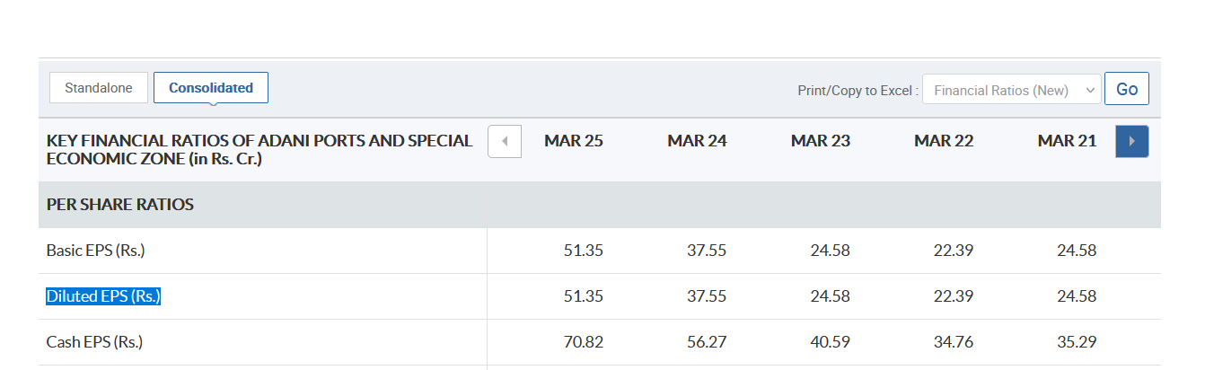

Make sure for each company **consolidated is selected.**

**After two tables are made, just divide using excel.**

**Here are the links:**

1. Adani Ports & SEZ – <https://www.moneycontrol.com/financials/adaniportsandspecialeconomiczone/consolidated-ratiosVI/MPS#MPS>
2. Asian Paints – <https://www.moneycontrol.com/financials/asianpaints/ratiosVI/AP31>
3. Axis Bank – <https://www.moneycontrol.com/financials/axisbank/ratiosVI/AB16>
4. Bajaj Finserv – <https://www.moneycontrol.com/financials/bajajfinserv/ratiosVI/BF04>
5. Bajaj Finance – <https://www.moneycontrol.com/financials/bajajfinance/ratiosVI/BAF>
6. Bharat Electronics – <https://www.moneycontrol.com/financials/bharatelectronic/ratiosVI/BE03>
7. Bharti Airtel – <https://www.moneycontrol.com/financials/bhartiairtel/ratiosVI/BA08>
8. Eternal Ltd – [https://www.moneycontrol.com/financials/eternal/ratiosVI/Z](https://www.moneycontrol.com/financials/eternal/ratiosVI/Z?utm_source=chatgpt.com)
9. HCL Technologies – <https://www.moneycontrol.com/financials/hcltechnologies/ratiosVI/HCL02>
10. HDFC Bank –<https://www.moneycontrol.com/financials/hdfcbank/ratiosVI/HDF01>
11. Hindustan Unilever –<https://www.moneycontrol.com/financials/hindustanunilever/ratiosVI/HU>
12. ICICI Bank – <https://www.moneycontrol.com/financials/icicibank/ratiosVI/ICI02>
13. Infosys – <https://www.moneycontrol.com/financials/infosy/ratiosVI/IT>
14. ITC –<https://www.moneycontrol.com/financials/itc/ratiosVI/ITC>
15. Kotak Mahindra Bank – <https://www.moneycontrol.com/financials/kotakmahbank/ratiosVI/KMB>
16. Larsen & Toubro – <https://www.moneycontrol.com/financials/larsentoubro/ratiosVI/LT>
17. Mahindra & Mahindra –<https://www.moneycontrol.com/financials/mahindramahindra/ratiosVI/MM>
18. Maruti Suzuki – <https://www.moneycontrol.com/financials/marutisuzukiindia/ratiosVI/MS24>
19. NTPC – <https://www.moneycontrol.com/financials/ntpc/ratiosVI/NTP#NTP>
20. Power Grid Corp – <https://www.moneycontrol.com/financials/powergridcorpindia/ratiosVI/PGC>
21. Reliance Industries –<https://www.moneycontrol.com/financials/relianceindustries/ratiosVI/RI>
22. State Bank of India – <https://www.moneycontrol.com/financials/statebankindia/ratiosVI/SBI>
23. Sun Pharma –<https://www.moneycontrol.com/financials/sunpharmaceuticalindustries/ratiosVI/SPI>
24. Tata Motors – <https://www.moneycontrol.com/financials/tatamotors/ratiosVI/TM03>
25. Tata Steel – <https://www.moneycontrol.com/financials/tatasteel/ratiosVI/TIS#TIS>
26. Tata Consultancy Services (TCS) – <https://www.moneycontrol.com/financials/tataconsultancyservices/ratiosVI/TCS>
27. Tech Mahindra – <https://www.moneycontrol.com/financials/techmahindra/ratiosVI/TM4>
28. Titan Company – <https://www.moneycontrol.com/financials/titancompany/ratiosVI/TI01#TI01>
29. Trent – <https://www.moneycontrol.com/financials/trent/ratiosVI/T04#T04>
30. UltraTech Cement – <https://www.moneycontrol.com/financials/ultratechcement/ratiosVI/UTC01#UTC01>